**Sprint 2 Plan**

**“DeliverMe”**

Jeffrey Chan (PO)

Avery Sio (Scrum Master)

Daniel Tjandra

Brian Wan

Hasaan Javed

Justin Lau

**Sprint completion date:** Feb 18, 2018

**Revision date:** Feb 5, 2018

**Goal:** To implement a “transactions page” that consist of real time updates conveying locations of requesters and drivers.

**Sprint 2:**

1. (8) As a non-regular user, I want to be able to see real-time updates around me so that I can find the right “partner” for my request quickly and easily.
   1. Task 1: Implement HTML/CSS website skeleton
   2. Task 2: Learn about Google API map
2. (8) As a user, I want to be able to login and access my account to set up my profile so that I can more easily communicate with my “partner.”
   1. Task 1: Learn about Google API login
   2. Task 2: Learn about storing data into a database

**Team Roles:**

Jeffrey Chan - Product Owner, Backend

Avery Sio - Scrum Master, Designer

Daniel Tjandra - Programmer, Backend

Brian Wan - Programmer, Designer

Hasaan Javed - Programmer, Designer

Justin Lau - Programmer, Designer

**Task Assignments:**

Daniel: Backend- Message board research

Justin: U1-Bootstrap

Hasaan: Venmo- API integration

Brian: U1-HTML/CSS

Jeffery: User Login and Security

Avery: U1-Django Routing

**Initial Burnup Chart:**

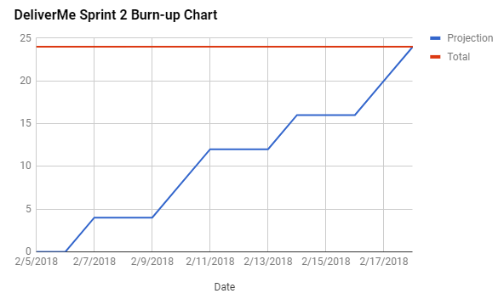

**Initial Scum Board:**

<https://trello.com/b/StPvbOqY/cmps-183-scrum-board>

**Scrum Times:**

Wednesdays 3-7PM

Sat, Sun 1-5PM